JAMESTOWN AT DARIEN |
JAMESTOWN AT DARIEN
Executive Memorandum
Approved PUD | Coastal Georgia

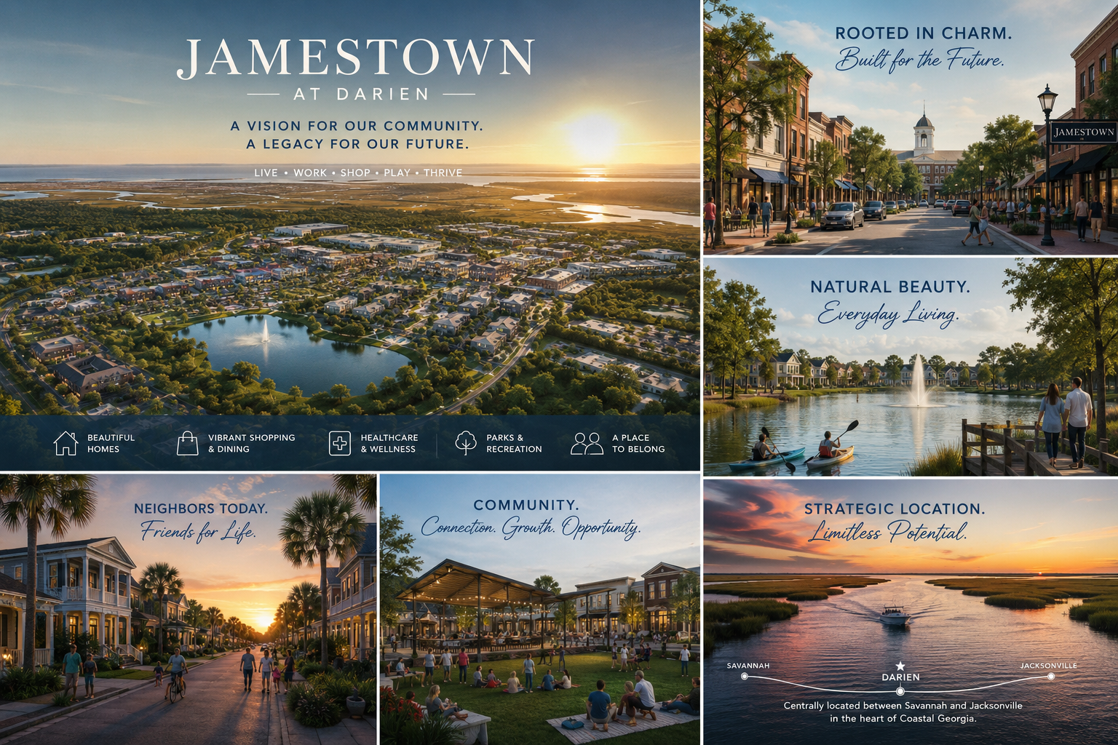

Confidential and Proprietary

Executive Development Dashboard

Metric | Reported Detail
Property | Jamestown at Darien
Street Address | Highway 251, Darien, Georgia 31305
Seller | HD, a Desai Corporation
Jurisdiction | City of Darien / McIntosh County, Georgia
Market Position | Savannah-Brunswick Coastal Growth Corridor
Gross Surveyed Acreage | 933.393± acres
Estimated Upland Acreage* | Approximately 750± acres
ALTA Survey Date | May 7, 2026
PUD Approval Date | April 23, 2026
Entitlement Status | Approved Planned Unit Development
Municipal Utility Framework | City of Darien water and sewer; capacity subject to verification
Interstate Frontage | Approximately 2,500 linear feet on Interstate 95
Additional Frontage / Access | Georgia Highway 251 and U.S. Highway 17
Residential Density | Up to 8 dwelling units per acre
Multifamily Density | Up to 24 units per acre
Commercial Intensity | Up to 40,000 square feet per acre
Development Readiness | PUD approved, ALTA complete, conceptual master plan complete

Approved Development Rights and Product Optionality
The approved PUD creates a broad development framework intended to accommodate multiple product types and long-term market changes.

Use Category | Entitlement Basis | Potential Development Strategy
Single-Family Residential | Up to 8 dwelling units per acre | Detached residential villages, cottage product, active adult, lifestyle communities, production residential
Multifamily Residential | Up to 24 units per acre | Apartments, build-to-rent, workforce housing, active adult multifamily, townhome variants
Commercial Development | Up to 40,000 square feet per acre | Retail, restaurants, medical, professional office, hospitality, hotels, service commercial
Civic / Institutional | Permitted within PUD framework | Schools, municipal facilities, healthcare, YMCA or community facilities, public-serving uses
Recreational / Open Space | Permitted and shown conceptually | Lakes, canals, parks, trails, community recreation, sports and amenity corridors
Mixed-Use Development | Permitted | Village center, residential over retail, neighborhood services, commercial gateways
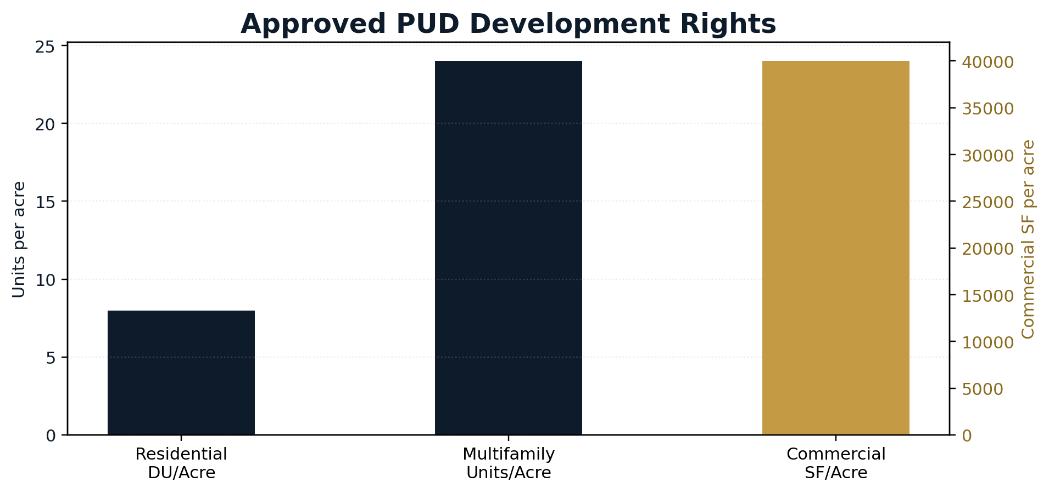

Regional Access and Economic Drivers
Darien should be presented as a Coastal Georgia growth-corridor opportunity rather than a local isolated development. The property is positioned to benefit from regional demand drivers in Brunswick, Savannah, the Golden Isles, and the Interstate 95 corridor.
Destination | Approx. Drive Time | Strategic Relevance
Downtown Darien | 5 minutes | Local services and municipal identity
Brunswick | 25 minutes | Regional employment and services
Port of Brunswick | 30 minutes | Automotive import/export, logistics, and transportation employment
FLETC | 30 minutes | Stable federal employment and training center
St. Simons Island | 40 minutes | Golden Isles lifestyle demand
Jekyll Island | 45 minutes | Tourism and coastal recreation
Richmond Hill | 50 minutes | Savannah-area residential growth node
Savannah Airport | 60 minutes | Regional air access
Downtown Savannah | 60-70 minutes | Logistics, tourism, employment, and institutional demand
Jacksonville Airport | 75-90 minutes | Additional regional air access
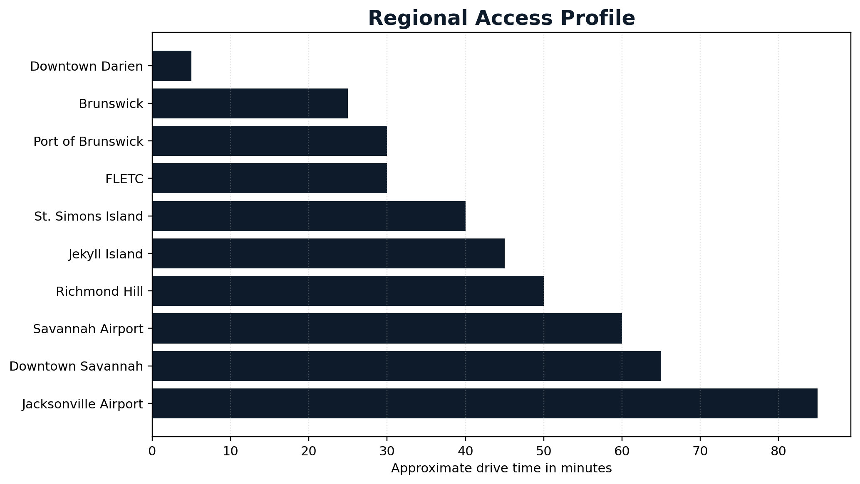

Primary Regional Demand Drivers
Economic Driver | Strategic Significance
Port of Savannah | Container logistics, distribution, import/export growth, and broader Savannah-region employment demand
Port of Brunswick | Automotive / RoRo logistics, port-related employment, transportation and distribution demand
Hyundai Motor Group Metaplant | Multi-billion-dollar regional advanced manufacturing investment with broader supplier and housing impacts
Gulfstream Aerospace | Major Coastal Georgia employer and high-wage advanced manufacturing anchor
FLETC | Federal training center creating stable government-related demand in the Brunswick area
Southeast Georgia Health System | Regional healthcare provider and employment anchor
Golden Isles Tourism Economy | Hospitality, recreation, second-home, and lifestyle demand from St. Simons, Sea Island, and Jekyll Island
Interstate 95 Corridor | Major East Coast logistics and migration corridor supporting long-term corridor demand

Benefits of Jamestown to the Region

Large portion of the site is dedicated to commercial development to help bring investor dollars to the region and support growing population with restaurants, shops, and essential needs.
Multifamily Residential approved to support growing manufacturing industries.

Key Links
Georgia Ports Authority - https://gaports.com
Port of Brunswick - https://gaports.com/facilities/port-of-brunswick/
McIntosh County Industrial Development Authority - https://www.mcintoshga.com
City of Darien - https://www.cityofdarienga.com
FLETC Glynco - https://www.fletc.gov
Golden Isles Tourism - https://www.goldenisles.com
Southeast Georgia Health System - https://www.sghs.org

